Ex01 UML:

Use Case Diagram:

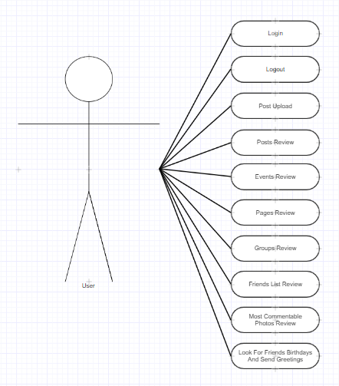

Class Diagram:

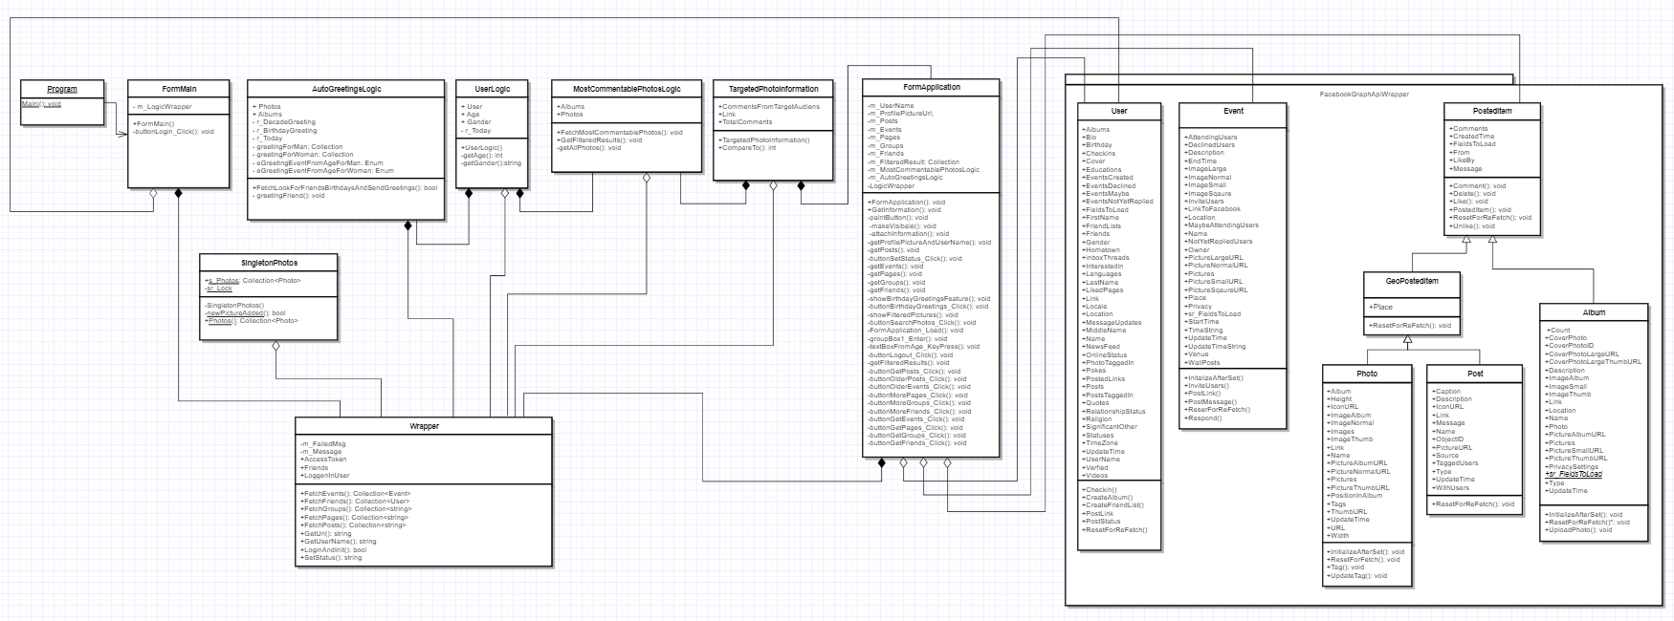

Sequence Diagram:

This sequence presents a new feature who posted an automatically **personalized** happy birthday greeting for friends who have birthday.

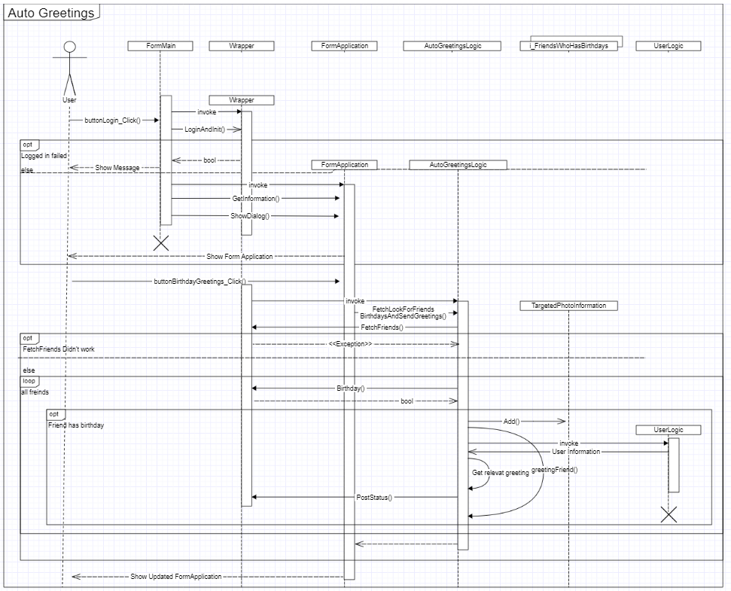

This sequence presents a new feature who look after the most commentable photos by a specific target audience (by age, gender and relationship status).

